Supplementary Information

Figures
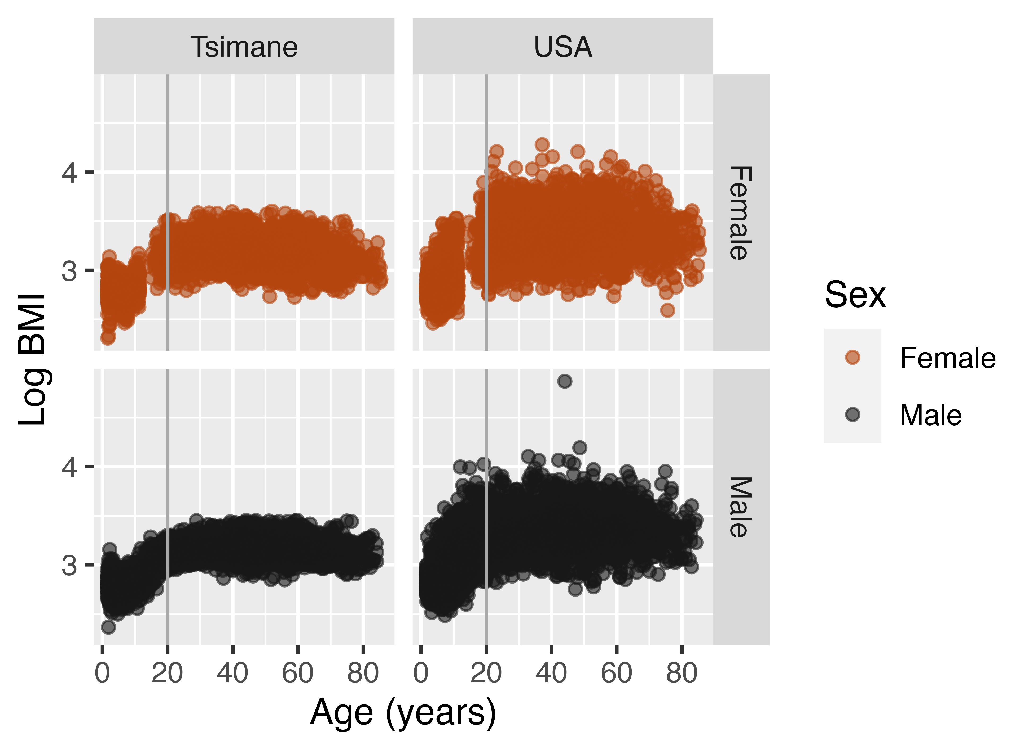
Fig S1. Raw natural logged body mass index (BMI) values by age and sex among the Tsimane and in the USA.

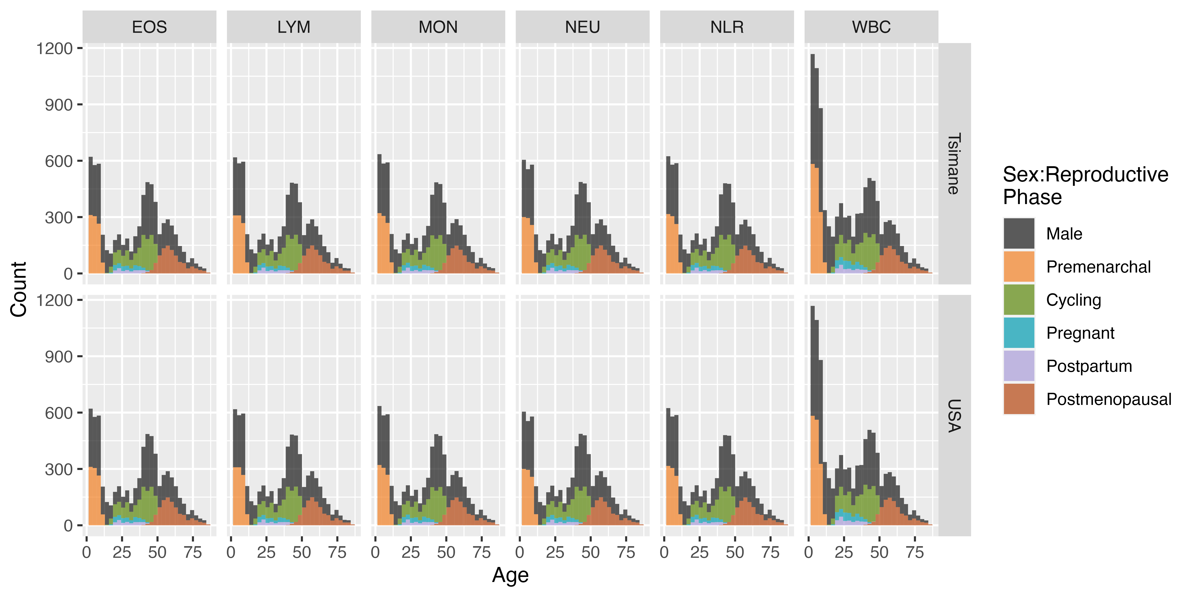
Fig S2. Final matched sample sizes by measure, population, age, and sex:female reproductive phase.

Tables
Table S1. Final matched sample sizes by measure, population, and sex:female reproductive phase.
Measure | Population | Male | Premenarchal | Cycling | Pregnant | Postpartum | Postmenopausal
WBC | Tsimane | 5320 | 1531 | 1365 | 286 | 203 | 934
WBC | USA | 5320 | 1531 | 1365 | 286 | 203 | 934
NEU | Tsimane | 3669 | 912 | 1154 | 194 | 141 | 931
NEU | USA | 3669 | 912 | 1154 | 194 | 141 | 931
LYM | Tsimane | 3673 | 945 | 1149 | 184 | 142 | 923
LYM | USA | 3673 | 945 | 1149 | 184 | 142 | 923
NLR | Tsimane | 3678 | 943 | 1146 | 186 | 140 | 919
NLR | USA | 3678 | 943 | 1146 | 186 | 140 | 919
MON | Tsimane | 3701 | 955 | 1151 | 195 | 142 | 927
MON | USA | 3701 | 955 | 1151 | 195 | 142 | 927
EOS | Tsimane | 3678 | 939 | 1144 | 192 | 139 | 926
EOS | USA | 3678 | 939 | 1144 | 192 | 139 | 926

Table S2. Number and corresponding percentage of unique participants out of the total THLHP sample by measure and sex:female reproductive phase.
Measure | Male | Premenarchal | Cycling | Pregnant | Postpartum | Postmenopausal
WBC | 3181 (59.79%) | 1193 (77.92%) | 848 (62.12%) | 258 (90.21%) | 195 (96.06%) | 375 (40.15%)
NEU | 2038 (55.55%) | 721 (79.06%) | 712 (61.7%) | 179 (92.27%) | 140 (99.29%) | 373 (40.06%)
LYM | 2052 (55.87%) | 736 (77.88%) | 711 (61.88%) | 169 (91.85%) | 141 (99.3%) | 371 (40.2%)
NLR | 2052 (55.79%) | 735 (77.94%) | 708 (61.78%) | 172 (92.47%) | 139 (99.29%) | 372 (40.48%)
MON | 2057 (55.58%) | 741 (77.59%) | 713 (61.95%) | 180 (92.31%) | 141 (99.3%) | 372 (40.13%)
EOS | 2043 (55.55%) | 728 (77.53%) | 706 (61.71%) | 177 (92.19%) | 138 (99.28%) | 372 (40.17%)

Table S3. Ages and values at which the absolute difference in immune outcomes between females and their male counterparts is greatest, separated by female reproductive phase, population, and immune measure.
Population | Measure | Reproductive Phase | Age | Parity | Bias | Female Value | Male Value | Percent Difference
Tsimane | LYM | Premenarchal | 2 | 0 | Male | 5718 cells/µl (95% CI: 5565-5871) | 6107 cells/µl (95% CI: 5950-6265) | 6% (95% CI: 4%, 9%)
Tsimane | MON | Premenarchal | 11 | 0 | Female | 79 cells/µl (95% CI: 66-92) | 58 cells/µl (95% CI: 50-65) | 37% (95% CI: 15%, 59%)
USA | LYM | Premenarchal | 2 | 0 | Female | 3880 cells/µl (95% CI: 3775-3986) | 3533 cells/µl (95% CI: 3445-3620) | 10% (95% CI: 7%, 13%)
USA | EOS | Premenarchal | 2 | 0 | Male | 218 cells/µl (95% CI: 200-236) | 262 cells/µl (95% CI: 249-275) | 17% (95% CI: 10%, 24%)
USA | MON | Premenarchal | 7 | 0 | Male | 535 cells/µl (95% CI: 518-552) | 592 cells/µl (95% CI: 580-603) | 10% (95% CI: 7%, 12%)
Tsimane | WBC | Cycling | 14 | 3 | Male | 10682 cells/µl (95% CI: 10184-11180) | 12229 cells/µl (95% CI: 12024-12434) | 13% (95% CI: 9%, 17%)
Tsimane | NEU | Cycling | 16 | 3 | Male | 5285 cells/µl (95% CI: 4943-5626) | 5983 cells/µl (95% CI: 5785-6181) | 12% (95% CI: 6%, 17%)
Tsimane | LYM | Cycling | 14 | 3 | Male | 3225 cells/µl (95% CI: 3009-3441) | 3835 cells/µl (95% CI: 3718-3952) | 16% (95% CI: 10%, 22%)
Tsimane | EOS | Cycling | 14 | 3 | Male | 1603 cells/µl (95% CI: 1378-1828) | 2216 cells/µl (95% CI: 2112-2321) | 28% (95% CI: 18%, 38%)
Tsimane | NLR | Cycling | 14 | 3 | Female | 1.99 ratio (95% CI: 1.77-2.21) | 1.69 ratio (95% CI: 1.62-1.76) | 18% (95% CI: 5%, 31%)
USA | WBC | Cycling | 14 | 3 | Female | 7608 cells/µl (95% CI: 7296-7921) | 6768 cells/µl (95% CI: 6647-6888) | 12% (95% CI: 8%, 17%)
USA | NEU | Cycling | 14 | 3 | Female | 4249 cells/µl (95% CI: 3976-4522) | 3630 cells/µl (95% CI: 3511-3750) | 17% (95% CI: 10%, 25%)
USA | EOS | Cycling | 14 | 3 | Male | 207 cells/µl (95% CI: 179-235) | 246 cells/µl (95% CI: 237-255) | 16% (95% CI: 4%, 27%)
USA | MON | Cycling | 26 | 3 | Male | 507 cells/µl (95% CI: 482-532) | 598 cells/µl (95% CI: 577-618) | 15% (95% CI: 11%, 19%)
USA | NLR | Cycling | 49 | 3 | Female | 2.22 ratio (95% CI: 2.14-2.31) | 2.05 ratio (95% CI: 2-2.11) | 8% (95% CI: 4%, 12%)
Tsimane | WBC | Pregnant | 17 | 3 | Male | 10578 cells/µl (95% CI: 9631-11524) | 11862 cells/µl (95% CI: 11637-12088) | 11% (95% CI: 3%, 19%)
Tsimane | LYM | Pregnant | 21 | 3 | Male | 2837 cells/µl (95% CI: 2520-3154) | 3641 cells/µl (95% CI: 3481-3801) | 22% (95% CI: 13%, 31%)
Tsimane | EOS | Pregnant | 30 | 3 | Male | 1307 cells/µl (95% CI: 1034-1580) | 1770 cells/µl (95% CI: 1625-1914) | 26% (95% CI: 11%, 42%)
Tsimane | NLR | Pregnant | 31 | 3 | Female | 2.43 ratio (95% CI: 2.22-2.65) | 1.79 ratio (95% CI: 1.7-1.88) | 36% (95% CI: 24%, 48%)
USA | WBC | Pregnant | 30 | 3 | Female | 8908 cells/µl (95% CI: 8514-9302) | 7357 cells/µl (95% CI: 7185-7528) | 21% (95% CI: 16%, 26%)
USA | NEU | Pregnant | 29 | 3 | Female | 6003 cells/µl (95% CI: 5584-6422) | 4270 cells/µl (95% CI: 4116-4425) | 41% (95% CI: 31%, 50%)
USA | LYM | Pregnant | 38 | 3 | Male | 1946 cells/µl (95% CI: 1763-2130) | 2242 cells/µl (95% CI: 2176-2308) | 13% (95% CI: 5%, 21%)
USA | EOS | Pregnant | 17 | 3 | Male | 161 cells/µl (95% CI: 103-218) | 241 cells/µl (95% CI: 231-251) | 33% (95% CI: 9%, 57%)
USA | NLR | Pregnant | 29 | 3 | Female | 3.14 ratio (95% CI: 2.9-3.38) | 2 ratio (95% CI: 1.92-2.09) | 57% (95% CI: 45%, 69%)
Tsimane | MON | Postpartum | 47 | 3 | Female | 239 cells/µl (95% CI: 113-365) | 65 cells/µl (95% CI: 58-72) | 266% (95% CI: 73%, 460%)
USA | MON | Postpartum | 24 | 3 | Male | 488 cells/µl (95% CI: 442-535) | 603 cells/µl (95% CI: 582-623) | 19% (95% CI: 11%, 27%)
Tsimane | EOS | Postmenopausal | 59 | 3 | Female | 1864 cells/µl (95% CI: 1730-1998) | 1608 cells/µl (95% CI: 1492-1724) | 16% (95% CI: 8%, 24%)
Tsimane | NLR | Postmenopausal | 84 | 3 | Male | 2.02 ratio (95% CI: 1.76-2.28) | 2.61 ratio (95% CI: 2.29-2.93) | 23% (95% CI: 13%, 32%)
USA | NEU | Postmenopausal | 58 | 3 | Male | 3861 cells/µl (95% CI: 3733-3990) | 4151 cells/µl (95% CI: 4029-4273) | 7% (95% CI: 4%, 10%)
USA | LYM | Postmenopausal | 53 | 3 | Female | 2294 cells/µl (95% CI: 2230-2357) | 2064 cells/µl (95% CI: 2002-2127) | 11% (95% CI: 8%, 14%)
USA | EOS | Postmenopausal | 75 | 3 | Male | 187 cells/µl (95% CI: 170-204) | 224 cells/µl (95% CI: 205-243) | 16% (95% CI: 9%, 24%)
USA | MON | Postmenopausal | 83 | 3 | Male | 571 cells/µl (95% CI: 541-601) | 670 cells/µl (95% CI: 604-736) | 15% (95% CI: 10%, 19%)
USA | NLR | Postmenopausal | 83 | 3 | Male | 2.3 ratio (95% CI: 2.04-2.57) | 2.84 ratio (95% CI: 2.59-3.1) | 19% (95% CI: 10%, 28%)

Table S4. Model terms, statistics, and p-values for Tsimane-specific models.
Population | Measure | Term | RepPhase | EDF | F-statistic | P-value | Sex:Reproductive Phase
Tsimane | WBC | s(Age) | Cycling | 1.022 | 9.138 | 0.003 | Cycling
Tsimane | WBC | s(Age) | Male | 5.294 | 184.778 | <0.001 | Male
Tsimane | WBC | s(Age) | Postmenopausal | 1.030 | 8.204 | 0.004 | Postmenopausal
Tsimane | WBC | s(Age) | Postpartum | 1.157 | 1.852 | 0.087 | Postpartum
Tsimane | WBC | s(Age) | Premenarchal | 1.019 | 0.008 | 0.972 | Premenarchal
Tsimane | WBC | s(Age) | Pregnant | 1.112 | 0.753 | 0.388 | Pregnant
Tsimane | WBC | s(Parity) | Cycling | 1.814 | 0.557 | 0.557 | Cycling
Tsimane | WBC | s(Parity) | Postmenopausal | 1.018 | 2.117 | 0.152 | Postmenopausal
Tsimane | WBC | s(Parity) | Postpartum | 1.015 | 1.756 | 0.187 | Postpartum
Tsimane | WBC | s(Parity) | Pregnant | 1.154 | 0.199 | 0.838 | Pregnant
Tsimane | NEU | s(Age) | Cycling | 1.083 | 3.034 | 0.085 | Cycling
Tsimane | NEU | s(Age) | Male | 6.484 | 18.196 | <0.001 | Male
Tsimane | NEU | s(Age) | Postmenopausal | 1.015 | 2.209 | 0.136 | Postmenopausal
Tsimane | NEU | s(Age) | Postpartum | 1.002 | 7.355 | 0.007 | Postpartum
Tsimane | NEU | s(Age) | Premenarchal | 1.774 | 19.409 | <0.001 | Premenarchal
Tsimane | NEU | s(Age) | Pregnant | 1.760 | 3.607 | 0.025 | Pregnant
Tsimane | NEU | s(Parity) | Cycling | 2.191 | 1.521 | 0.206 | Cycling
Tsimane | NEU | s(Parity) | Postmenopausal | 1.014 | 1.894 | 0.175 | Postmenopausal
Tsimane | NEU | s(Parity) | Postpartum | 1.005 | 0.767 | 0.382 | Postpartum
Tsimane | NEU | s(Parity) | Pregnant | 1.002 | 0.001 | 0.991 | Pregnant
Tsimane | LYM | s(Age) | Cycling | 1.013 | 4.059 | 0.045 | Cycling
Tsimane | LYM | s(Age) | Male | 7.946 | 266.968 | <0.001 | Male
Tsimane | LYM | s(Age) | Postmenopausal | 1.011 | 6.778 | 0.008 | Postmenopausal
Tsimane | LYM | s(Age) | Postpartum | 1.012 | 2.493 | 0.113 | Postpartum
Tsimane | LYM | s(Age) | Premenarchal | 1.010 | 37.483 | <0.001 | Premenarchal
Tsimane | LYM | s(Age) | Pregnant | 2.089 | 2.836 | 0.043 | Pregnant
Tsimane | LYM | s(Parity) | Cycling | 1.008 | 0.223 | 0.644 | Cycling
Tsimane | LYM | s(Parity) | Postmenopausal | 1.377 | 0.146 | 0.803 | Postmenopausal
Tsimane | LYM | s(Parity) | Postpartum | 1.010 | 0.089 | 0.786 | Postpartum
Tsimane | LYM | s(Parity) | Pregnant | 1.007 | 0.121 | 0.735 | Pregnant
Tsimane | EOS | s(Age) | Cycling | 1.027 | 0.013 | 0.972 | Cycling
Tsimane | EOS | s(Age) | Male | 7.829 | 22.199 | <0.001 | Male
Tsimane | EOS | s(Age) | Postmenopausal | 1.021 | 0.116 | 0.766 | Postmenopausal
Tsimane | EOS | s(Age) | Postpartum | 1.010 | 0.647 | 0.421 | Postpartum
Tsimane | EOS | s(Age) | Premenarchal | 1.873 | 9.796 | <0.001 | Premenarchal
Tsimane | EOS | s(Age) | Pregnant | 2.136 | 6.268 | 0.002 | Pregnant
Tsimane | EOS | s(Parity) | Cycling | 5.188 | 3.434 | 0.002 | Cycling
Tsimane | EOS | s(Parity) | Postmenopausal | 1.007 | 9.941 | 0.002 | Postmenopausal
Tsimane | EOS | s(Parity) | Postpartum | 1.330 | 0.716 | 0.348 | Postpartum
Tsimane | EOS | s(Parity) | Pregnant | 1.057 | 0.009 | 0.987 | Pregnant
Tsimane | MON | s(Age) | Cycling | 1.054 | 4.411 | 0.043 | Cycling
Tsimane | MON | s(Age) | Male | 5.716 | 8.299 | <0.001 | Male
Tsimane | MON | s(Age) | Postmenopausal | 3.058 | 2.111 | 0.114 | Postmenopausal
Tsimane | MON | s(Age) | Postpartum | 3.306 | 4.492 | 0.001 | Postpartum
Tsimane | MON | s(Age) | Premenarchal | 1.001 | 0.048 | 0.826 | Premenarchal
Tsimane | MON | s(Age) | Pregnant | 1.008 | 2.109 | 0.147 | Pregnant
Tsimane | MON | s(Parity) | Cycling | 1.007 | 0.008 | 0.956 | Cycling
Tsimane | MON | s(Parity) | Postmenopausal | 1.005 | 0.318 | 0.576 | Postmenopausal
Tsimane | MON | s(Parity) | Postpartum | 2.206 | 2.434 | 0.159 | Postpartum
Tsimane | MON | s(Parity) | Pregnant | 1.004 | 0.053 | 0.825 | Pregnant
Tsimane | NLR | s(Age) | Cycling | 2.210 | 1.396 | 0.242 | Cycling
Tsimane | NLR | s(Age) | Male | 6.940 | 75.381 | <0.001 | Male
Tsimane | NLR | s(Age) | Postmenopausal | 2.036 | 2.460 | 0.057 | Postmenopausal
Tsimane | NLR | s(Age) | Postpartum | 1.056 | 0.057 | 0.921 | Postpartum
Tsimane | NLR | s(Age) | Premenarchal | 1.000 | 71.831 | <0.001 | Premenarchal
Tsimane | NLR | s(Age) | Pregnant | 2.289 | 5.299 | 0.003 | Pregnant
Tsimane | NLR | s(Parity) | Cycling | 1.560 | 0.318 | 0.683 | Cycling
Tsimane | NLR | s(Parity) | Postmenopausal | 5.706 | 2.466 | 0.040 | Postmenopausal
Tsimane | NLR | s(Parity) | Postpartum | 1.005 | 0.181 | 0.675 | Postpartum
Tsimane | NLR | s(Parity) | Pregnant | 1.003 | 0.034 | 0.860 | Pregnant

Table S5. Model terms, statistics, and p-values for USA-specific models.
Population | Measure | Term | RepPhase | EDF | F-statistic | P-value | Sex:Reproductive Phase
USA | WBC | s(Age) | Cycling | 1.033 | 1.329 | 0.280 | Cycling
USA | WBC | s(Age) | Male | 7.720 | 13.372 | <0.001 | Male
USA | WBC | s(Age) | Postmenopausal | 1.030 | 15.805 | <0.001 | Postmenopausal
USA | WBC | s(Age) | Postpartum | 1.782 | 1.243 | 0.290 | Postpartum
USA | WBC | s(Age) | Premenarchal | 1.752 | 31.142 | <0.001 | Premenarchal
USA | WBC | s(Age) | Pregnant | 2.808 | 30.719 | <0.001 | Pregnant
USA | WBC | s(Parity) | Cycling | 1.303 | 0.881 | 0.250 | Cycling
USA | WBC | s(Parity) | Postmenopausal | 1.018 | 1.566 | 0.203 | Postmenopausal
USA | WBC | s(Parity) | Postpartum | 1.017 | 0.384 | 0.535 | Postpartum
USA | WBC | s(Parity) | Pregnant | 1.009 | 2.663 | 0.100 | Pregnant
USA | NEU | s(Age) | Cycling | 1.034 | 0.885 | 0.349 | Cycling
USA | NEU | s(Age) | Male | 5.858 | 29.561 | <0.001 | Male
USA | NEU | s(Age) | Postmenopausal | 3.471 | 6.091 | <0.001 | Postmenopausal
USA | NEU | s(Age) | Postpartum | 1.755 | 1.074 | 0.334 | Postpartum
USA | NEU | s(Age) | Premenarchal | 1.001 | 0.046 | 0.830 | Premenarchal
USA | NEU | s(Age) | Pregnant | 3.006 | 24.243 | <0.001 | Pregnant
USA | NEU | s(Parity) | Cycling | 1.047 | 0.073 | 0.817 | Cycling
USA | NEU | s(Parity) | Postmenopausal | 1.018 | 1.017 | 0.308 | Postmenopausal
USA | NEU | s(Parity) | Postpartum | 1.020 | 0.403 | 0.530 | Postpartum
USA | NEU | s(Parity) | Pregnant | 1.809 | 4.266 | 0.009 | Pregnant
USA | LYM | s(Age) | Cycling | 1.448 | 8.040 | <0.001 | Cycling
USA | LYM | s(Age) | Male | 8.145 | 129.186 | <0.001 | Male
USA | LYM | s(Age) | Postmenopausal | 2.634 | 7.178 | <0.001 | Postmenopausal
USA | LYM | s(Age) | Postpartum | 1.018 | 1.849 | 0.165 | Postpartum
USA | LYM | s(Age) | Premenarchal | 2.017 | 180.463 | <0.001 | Premenarchal
USA | LYM | s(Age) | Pregnant | 2.150 | 3.974 | 0.012 | Pregnant
USA | LYM | s(Parity) | Cycling | 1.004 | 0.267 | 0.607 | Cycling
USA | LYM | s(Parity) | Postmenopausal | 1.002 | 0.279 | 0.597 | Postmenopausal
USA | LYM | s(Parity) | Postpartum | 1.313 | 0.220 | 0.642 | Postpartum
USA | LYM | s(Parity) | Pregnant | 1.008 | 0.091 | 0.767 | Pregnant
USA | EOS | s(Age) | Cycling | 1.003 | 3.629 | 0.057 | Cycling
USA | EOS | s(Age) | Male | 3.010 | 17.847 | <0.001 | Male
USA | EOS | s(Age) | Postmenopausal | 1.008 | 0.298 | 0.592 | Postmenopausal
USA | EOS | s(Age) | Postpartum | 1.001 | 0.269 | 0.605 | Postpartum
USA | EOS | s(Age) | Premenarchal | 1.000 | 0.397 | 0.527 | Premenarchal
USA | EOS | s(Age) | Pregnant | 1.375 | 0.331 | 0.765 | Pregnant
USA | EOS | s(Parity) | Cycling | 1.018 | 0.050 | 0.846 | Cycling
USA | EOS | s(Parity) | Postmenopausal | 1.010 | 2.671 | 0.099 | Postmenopausal
USA | EOS | s(Parity) | Postpartum | 1.008 | 0.330 | 0.572 | Postpartum
USA | EOS | s(Parity) | Pregnant | 1.012 | 1.781 | 0.183 | Pregnant
USA | MON | s(Age) | Cycling | 3.894 | 3.438 | 0.006 | Cycling
USA | MON | s(Age) | Male | 7.274 | 12.806 | <0.001 | Male
USA | MON | s(Age) | Postmenopausal | 1.012 | 14.609 | <0.001 | Postmenopausal
USA | MON | s(Age) | Postpartum | 1.005 | 1.191 | 0.273 | Postpartum
USA | MON | s(Age) | Premenarchal | 1.909 | 10.863 | <0.001 | Premenarchal
USA | MON | s(Age) | Pregnant | 2.490 | 15.172 | <0.001 | Pregnant
USA | MON | s(Parity) | Cycling | 1.534 | 0.624 | 0.503 | Cycling
USA | MON | s(Parity) | Postmenopausal | 1.619 | 0.275 | 0.804 | Postmenopausal
USA | MON | s(Parity) | Postpartum | 1.003 | 0.089 | 0.770 | Postpartum
USA | MON | s(Parity) | Pregnant | 1.001 | 2.874 | 0.090 | Pregnant
USA | NLR | s(Age) | Cycling | 1.002 | 21.725 | <0.001 | Cycling
USA | NLR | s(Age) | Male | 5.660 | 123.834 | <0.001 | Male
USA | NLR | s(Age) | Postmenopausal | 3.898 | 9.403 | <0.001 | Postmenopausal
USA | NLR | s(Age) | Postpartum | 1.146 | 0.180 | 0.844 | Postpartum
USA | NLR | s(Age) | Premenarchal | 1.489 | 14.189 | <0.001 | Premenarchal
USA | NLR | s(Age) | Pregnant | 3.325 | 65.932 | <0.001 | Pregnant
USA | NLR | s(Parity) | Cycling | 1.909 | 0.813 | 0.585 | Cycling
USA | NLR | s(Parity) | Postmenopausal | 5.317 | 1.896 | 0.069 | Postmenopausal
USA | NLR | s(Parity) | Postpartum | 1.003 | 1.116 | 0.291 | Postpartum
USA | NLR | s(Parity) | Pregnant | 1.019 | 20.734 | <0.001 | Pregnant

